**Research Proposal Ethics Checklist**  

To ensure integrity and safeguard the interests of researchers, participants and funders, all research conducted at or through the University of Stirling by members of staff, students and collaborators is subject to internal ethical scrutiny **prior** to the commencement of research (**Figure 1**).

If you are aware that your research requires ethical approval by one of the Research Ethics Committees (RECs), completion of this checklist is **not** required. Please complete a **Research Proposal Ethical Approval Form** for the appropriate committee (see below) and submit this, along with any supporting documentation, via email to the committee secretary:

* **Animal Welfare and Ethical Review Body (AWERB)** – for research involving animals in any way (allnon-human vertebrates and invertebrates).
* **NHS, Invasive or Clinical Research (NICR)** – for health/patient research requiring approval by the NHS Research Ethics Committee and other research involving physically invasive procedures or intrusive interventions on human participants.
* **General University Ethics Panel (GUEP)** – for all other research (social, digital, environmental etc.).
* **Ethics Checklist -** If you are unsure about the ethical implications of your research, please complete the following Checklist. A completed and signed Checklist is required for **all** research proposals that have not been submitted for ethical review to one of the above committees. Once complete, this Checklist should be submitted to [ethics@stir.ac.uk](mailto:ethics@stir.ac.uk).

**Figure 1: Ethics Decision Tree**

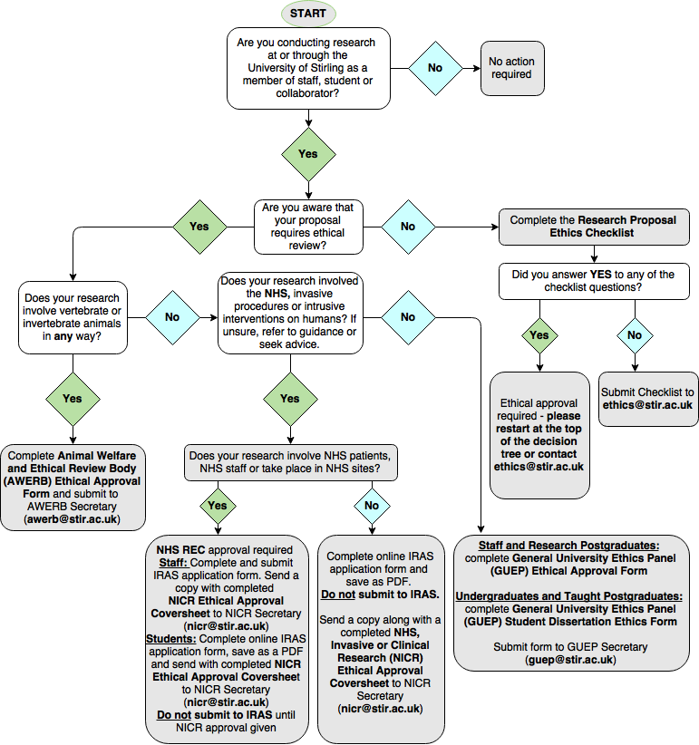

**Applicant details**

|  |
| --- |
| **Name of applicant:** Tom Wallace |
| **Faculty affiliation:** Social Sciences **Division:** SSE Sociology, Social Policy & Criminology  **Overseas campus:** If applicable click here to enter overseas campus affiliation |
| **Designation:** Research Postgraduate |
| **Email address of applicant: tom.wallace@stir.ac.uk** |
| **STUDENTS ONLY**  **Student ID number: 2231729**  **Degree programme:** PhD **Module code:** N/A  **Supervisor name:** Alasdair Rutherford |
| **STAFF ONLY**  **Job title:** Click here to enter text |

**Project details**

|  |  |
| --- | --- |
| **Project title:** UK charities on twitter | |
| **Project funder: None** | |
| **Project start date:** 08/01/2018 | **Project end date:** 13/08/2018 |
| **Short project description:**  There is currently no published research which systematically studies how UK charities are using Twitter. Most charities are making use of Twitter, among other social networks, but academic literature on the subject is scant. Studies which have been done in other countries have found that the size of organisations does not seem to affect how they use twitter. This seems unlikely in the UK context and this study will endeavour to measure how different size groups of charities engage with twitter differently. The paper makes use of network analysis tools including the niche network modelling technique exponential random graph modelling (ERGM). This paper will lay the foundation for further research on how the UK third sector interacts with social media.  This project will collect data on a random sample of charities through the twitter API. A random sample of 160 charities will be drawn from an existing secondary data set. Twitter handles for these charities will then be sourced from Google searches. Finally the main research data will comprise following links between the selected charities and twitter usage metrics such as number of tweets, number of followers or length of time on twitter. For the analysis the 160 charities will be divided into size groupings of 40 (small, medium, large, major) and analysis will proceed on the basis of comparing aggregates of the different size groups. Network maps will also be produced. No charity or handle will be identifiable in the output.  The data collected from twitter will only contain organisational twitter accounts. The sample will not include individuals. The data is not personal/sensitive and is not considered ‘human data’ by the ESRC or ‘personal data’ under the data protection act. The data is collected from an entirely public space where participant organisations expect to be observed. The data only comprises follower links and summary statistics, it does not track what the organisations are tweeting. The data is made available for research by Twitter through their API. The results will be full anonymised with no organisation identifiable. The data will be stored as if it were personal sensitive data on a password protected machines and encrypted cloud storage. The research will have no impact established online social structures or the participants and does not involve direct contact with any participant organisation. | |

**Please complete all sections which apply to your proposed research by checking Yes or No to each question.**

**SECTION A: Researcher safety**

|  |  |
| --- | --- |
| **A1.** Does the proposed research pose any particular risks to the researcher(s)?  Potential risks to consider include: working in a dangerous or isolated geographical area; lone working; working with equipment and manual handling; environmental hazards; chemical and biological hazards; and emotional risks associated with sensitive research. | **Yes  No** |
| If **YES** please provide brief details indicating the nature and level of risk (low, medium, high):  Click here to enter text | |
| |  | | --- | | ***PROCEED TO SECTION B*** | | |

**SECTION B: Research involving or impacting animals**

|  |  |  |
| --- | --- | --- |
| **B1. Does your research project involve animals in any way?**  If YES, please submit an application to the Animal Welfare and Ethical Review Body (AWERB) ([click here](https://stir.box.com/s/03p7ztbre4ognd1u85vrxh0yiqad7rho)). | **Yes  No** | |
| |  | | --- | | ***PROCEED TO SECTION C*** | | |

**SECTION C: Data protection, copyright and other considerations**

|  |  |
| --- | --- |
| **C1.** Does the proposed research involve accessing records of personal or confidential information? | **Yes  No** |
| **C2.** Does the proposed research involve the recording or use of audio-visual material for which consent is required?  *Answer* ***NO*** *if you are making use of material for which appropriate consent has already been gained e.g. utilisation of established databases* | **Yes  No** |
| **C3.** Does the proposed research involve the [remote acquisition of data](https://stir.box.com/v/IMREthics) from or  about human participants using the internet and its associated technologies | **Yes  No** |
| **C4.** Does the proposed research involve accessing potentially sensitive data through third parties? | **Yes  No** |
| **C5.** Does the proposed research involve reproducing [copyrighted work](https://www.gov.uk/government/uploads/system/uploads/attachment_data/file/375954/Research.pdf) in published form (other than brief citation)? | **Yes  No** |
| **C6.** Does the proposed work involve activities, which could temporarily or permanently damage or disturb the environment, or archaeological remains and artefacts? | **Yes  No** |
| **C7.** Does the proposed work involve a potential conflict of interest or raise ethical issues regarding the source of funding or where publication of research data may be restricted? | **Yes  No** |
| |  | | --- | | ***PROCEED TO SECTION D*** | | |

**SECTION D: Research involving human participants**

|  |  |
| --- | --- |
| **D1. Does the proposed research involve human participants?**  **If YES *PLEASE COMPLETE QUESTIONS D2 – D19 below***  **If you answer YES to any of these questions, please review the Flowchart at the top of the form.**  ***If NO PROCEED TO SIGN AND DATE FORM*** | **Yes  No** |
| **D2.** Does the proposed research involve the recruitment of staff or patients  through the NHS or the use of NHS data or premises and/or equipment? | **Yes  No** |
| **D3.** Does the proposed research involve physically invasive procedures? | **Yes  No** |
| **D4.** Is the proposed research study a clinical trial of an [investigational medicinal product?](http://www.ct-toolkit.ac.uk/glossary/?letter=I&postcategory=-1) | **Yes  No** |
| **D5.** Does the proposed research involve a non-CE marked [medical device](http://www.hra.nhs.uk/documents/2013/09/approval-of-medical-devices-research-version-2-april-2008.pdf) or a device which has been modified outside of its CE mark? | **Yes  No** |
| **D6.** Does the proposed research involve exposure to [ionising radiation](http://www.hra.nhs.uk/resources/before-you-apply/types-of-study/knowledgebase-ionising-radiation-2/)? | **Yes  No** |
| **D7.** Does the proposed research involve the processing of information held by the [Human Fertilisation and Embryology Authority](http://www.hfea.gov.uk/) (HFEA) without consent? | **Yes  No** |
| **D8.** Does the proposed research involve the [collection of tissue](http://www.hra.nhs.uk/resources/before-you-apply/types-of-study/human-tissue-2/) or other human material e.g. blood, biopsies, urine etc. | **Yes  No** |
| **D9.** Does the proposed research involve [intrusive interventions](https://stir.box.com/s/gjjxlyivsbhtk333m3jb0iu2n2oorku5) e.g. the administration of drugs or vigorous physical exercise? | **Yes  No** |
| **D10.** Does the proposed research involve the bodies or human materials from deceased persons? | **Yes  No** |
| **D11.** Does the proposed research involve interviews with participants or the use of questionnaires? | **Yes  No** |
| **D12.** Does the proposed research involve [vulnerable adults](http://www.gov.scot/Publications/2009/01/30112831/3)? | **Yes  No** |
| **D13.** Does the proposed research involve children and young people under the age of eighteen? | **Yes  No** |
| **D14.** Does the proposed research involve participants who have particular communication/linguistic or developmental requirements? | **Yes  No** |
| **D15.** Does the proposed research involve [sensitive topics](http://www.esrc.ac.uk/funding/guidance-for-applicants/research-ethics/research-that-may-require-full-ethics-review/)? | **Yes  No** |
| **D16.** Could the proposed research induce psychological stress, anxiety, humiliation or cause more than minimal pain? | **Yes  No** |
| **D17.** Does the proposed research involve [deception, concealment or covert observation](https://stir.box.com/s/gjjxlyivsbhtk333m3jb0iu2n2oorku5)? | **Yes  No** |
| **D18.** Does the proposed research involve prisoners or those on court orders? | **Yes  No** |
| **D19.** Will the proposed research be undertaken outside of the UK or involve participants from outside the UK? | **Yes  No** |

If you have answered **YES** to any of these questions, further ethical review is required. Please seek advice from Research and Innovation Services ([ethics@stir.ac.uk](mailto:ethics@stir.ac.uk)) orcomplete the appropriate **Research Proposal Ethics Approval form**. If you have answered **NO** to all of the questions, sign and date the form and email it to [ethics@stir.ac.uk](mailto:ethics@stir.ac.uk).

By signing below (digital signatures accepted), you certify that the information provided is true and correct to the best of your knowledge. Applicants should expect to get an acknowledgement within 48 hours that their checklist has been received. If you do not hear, please contact [ethics@stir.ac.uk](mailto:ethics@stir.ac.uk)

**C:\Users\tw18\Dropbox\signature.jpgSTUDENTS**

**Applicant’s signature: Date:** 27/11/2017

**Supervisor’s signature: Date:** 30/11/2017

**STAFF**

**Applicant’s signature:**  **Date:** Click here to enter a date

|  |
| --- |
| **FOR ADMINISTRATIVE USE ONLY:**  **Date received:** Click here to enter a date **Reference number:** Select year**/**Click here to enter number  **Checklist completed, signed and dated  For archiving  Query if further ethical review required**  **Notes:**  Click here to enter text |